ARC Week at Glance
Subject: Math Course: IB AA Y2 Year Grade: 12th Dates: 8.11 to 8.15
Standard(s):

Assessment(s): ☐ Quiz ☐ Unit Test ☒ Project ☐ Lab ☐
 | Learning Target  (I am learning about…) | Criteria for Success  (I can…) | Opening  (10 - 15 Mins) | Work-Session  (20 - 25 mins) | Closing  (5 - 10 mins) | Literacy Tasks/Focus
 |  |  | (Include at least one/two formatives*in any part of the lesson as needed)
Monday | I am learning about limits of a function. | I can determine the limit of a function. | Go over Homework 5A and 5B Limits and Asymptotes  Mini Lesson on Vertical Asymptotes  Diagnostic on Limits  GA DOE Task | I Do, We Do, You DO  GA DOE Task  Limits | How are you feeling about limits?
Tuesday | I am learning about derivatives and how they are connected to the slope of a tangent line and instant rate of change at a point. | I can describe how derivatives are the slope of the tangent line and the instant rate of change at a point. | Surfer Board Illustration and Slope at anypoint is the derivative of the function at that point  Draw or find a graph of a parabola that opens downward, since that is the easiest to compare to a wave. Demonstrate how the surfboard can travel along the curve. Explain that its slope at any point is the derivative of the function at that point. | Derivative Infographic  Connect Derivatives with Physics  Show a position graph and explain what it represents. Write "position" on the board. Ask students to come up with a word for how quickly position changes. Write "velocity/speed" below the word "position." If they need help, act it out. Walk slowly, then fast across the room. Then ask "Ok, is there a word for how fast the velocity changes? Have them think about slowing down and speeding up when driving. Write "acceleration" below "velocity" on the board. Display or hand out graphs for position, velocity, and acceleration. You can even talk about "jerk" as an opportunity to go one more level to incorporate a third derivative.  The key here is getting students talking out loud or writing in complete sentences. Try to get a real discussion going. Encourage students to clearly verbalize the relationships. Have them look at the position graph and talk about it. You need them to speak out loud and hear classmates say plenty of statements like:  - "The car must be going faster here because the position is changing more quickly than it was."  - "When the velocity starts increasing more quickly, this means that the acceleration is increasing."  - "The car is driving at a steady rate (constant velocity) when the position graph is linear. The slope is constant, so the position is changing at a constant rate."  - "The car is stopped when the slope is zero. The position is constant."  Have students take time to really look in-depth at each graph and point to the different intervals and explain out loud. Make connections by labeling the position graph f(x), the velocity graph f'(x), and the acceleration graph f''(x). Start using the words "first derivative" and "second derivative" to introduce the new vocabulary.  Have students talk in groups  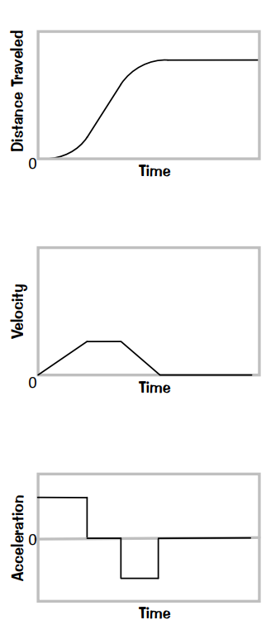 | How would you describe the derivative of a function? | Introducing Derivatives to your Calculus class
Wednesday | I am learning about finding the derivative of a function using the power rule. | I can find the derivative of a function using the power rule. | Warm Up:  Describing Position/Time, Velocity/Time and Acceleration/Time Graphs | 5CD Intro to Derivatives Guided Notes  Finding the Derivative of functions guided practice | Derivatives White Board Quick Check Activity
Thursday | I am learning about normal lines. | I can find the normal line given a point. | Warmup:  Derivatives | 5EF Tangent and Normal Lines | Tangent and Normal Lines  White Board Quick Check
Friday | I am able to determine the limit of a function.  I am able to find the derivative using the power rule.  I am able to describe that velocity/ time is the derivative of position/time.  I am able to determine the equation of a normal line given a point. | I can determine the limit of a function.  I can find the derivative by using the power rule.  I can describe velocity/time is the derivative of position/time.  I can determine the equation of a normal line given a point. | Quick Study Session before Quiz | Quiz:  Limits, Derivatives using the Power rule, Describing Derivatives, and Finding the Equation to a Normal Line | Have a Great Weekend!!!
*☐ Exit Ticket/Final Stretch Check ☒ Electronic Tools ☐ Dry Erase Boards – quick checks ☐ Turn & Talk Discussion (verbal responses) ☐ Teacher Observation – document Clipboard
☐ Quick Write/Draw ☐ Annotation ☐ Extended Writing ☐ Socratic Seminar ☐ Jigsaw ☐ Thinking Maps ☒ Worked Examples ☐ Other : ___________

